FHIR public测试服务器用户手册

谭红霞
tanhx05@taikanglife.com
2016-07-25

一、安装Firefox rest插件
http://jingyan.baidu.com/article/1876c8529b07e3890b137623.html

二、使用测试服务器
服务器：http://spark.furore.com/fhir

1. get patient
URL: http://spark.furore.com/fhir/Patient/d1
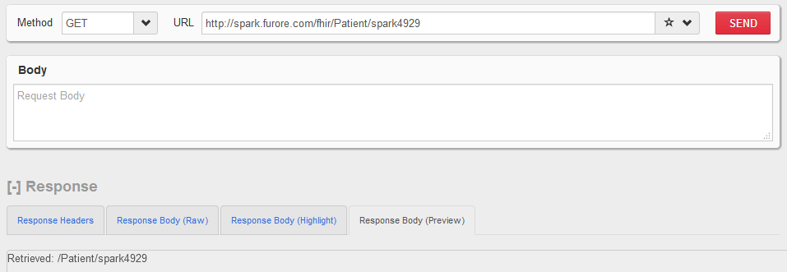

2. post patient
URL: http://spark.furore.com/fhir/Patient
参数如下：
<?xml version="1.0" encoding="utf-8"?>
<Patient xmlns="http://hl7.org/fhir">

<text>

<status value="generated" />

<div xmlns="http://www.w3.org/1999/xhtml">

<p>Harley N Hobbs</p>

<p>16 Pier Road</p>

<p>STANWARDINE IN THE FIELDS</p>

<p>SY4 7IW</p>

<p>Date of birth: 1966-06-07</p>

</div>

</text>

<identifier>

<use value="official" />

<type>

<coding>

<code value="SSN" />

</coding>

</type>

<system value="http://hl7.org/fhir/sid/us-ssn" />

<value value="1" />

</identifier>

<active value="true" />

<name>

<use value="official" />

<family value="Hobbs" />

<given value="Harley" />

</name>

<telecom>

<system value="phone" />

<value value="077 8169 8899" />

<use value="home" />

</telecom>

<gender value="male" />

<birthDate value="1966-06-07" />

<deceasedBoolean value="false" />

<address>

<use value="home" />

<text value="16 Pier Road, STANWARDINE IN THE FIELDS, SY4 7IW" />

<line value="16 Pier Road" />

<city value="STANWARDINE IN THE FIELDS" />

<postalCode value="SY4 7IW" />

</address>

<careProvider>

<reference value="Organization/1" />

</careProvider>

</Patient>

返回地址：http://spark.furore.com/fhir/Patient/spark4929
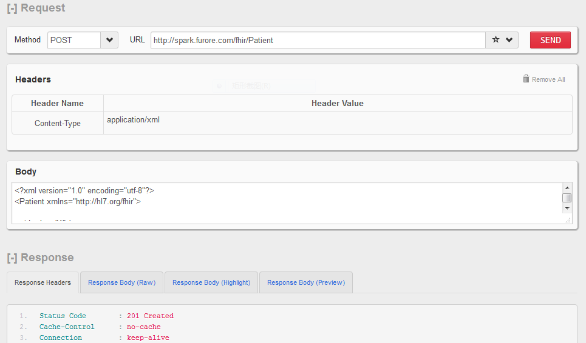
注意：设置head参数 Content-Type

3.put patient
URL: http://spark.furore.com/fhir/Patient/spark6331
参数如下：
<?xml version="1.0" encoding="utf-8"?>
<Patient xmlns="http://hl7.org/fhir">
<id value="spark6331" />
<text>

<status value="generated" />

<div xmlns="http://www.w3.org/1999/xhtml">

<p>Harley N Hobbs</p>

<p>16 Pier Road</p>

<p>STANWARDINE IN THE FIELDS</p>

<p>SY4 7IW</p>

<p>Date of birth: 1966-06-07</p>

</div>

</text>

<identifier>

<use value="official" />

<type>

<coding>

<code value="SSN" />

</coding>

</type>

<system value="http://hl7.org/fhir/sid/us-ssn" />

<value value="1" />

</identifier>

<active value="true" />

<name>

<use value="official" />

<family value="Hobbs" />

<given value="Harley-test" />

</name>

<telecom>

<system value="phone" />

<value value="077 8169 8899" />

<use value="home" />

</telecom>

<gender value="male" />

<birthDate value="1966-06-07" />

<deceasedBoolean value="false" />

<address>

<use value="home" />

<text value="16 Pier Road, STANWARDINE IN THE FIELDS, SY4 7IW" />

<line value="16 Pier Road" />

<city value="STANWARDINE IN THE FIELDS" />

<postalCode value="SY4 7IW" />

</address>

<careProvider>

<reference value="Organization/1" />

</careProvider>

</Patient>

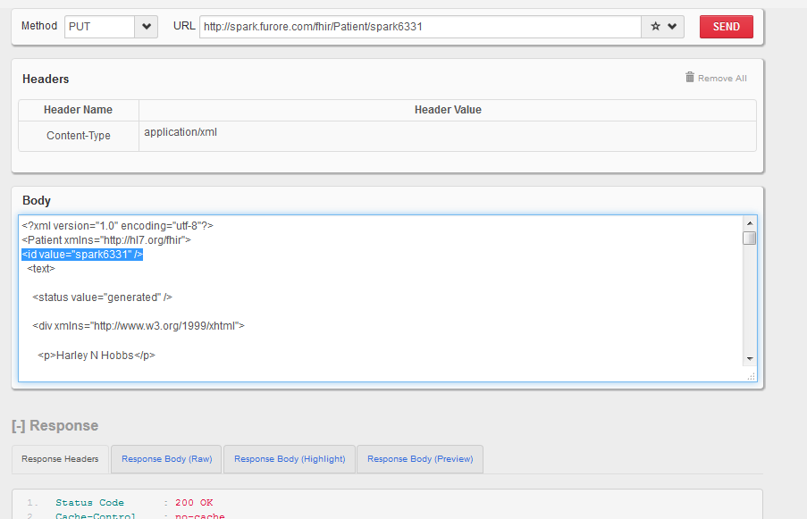
注：必须设置id value正确值

4.get history version
URL：http://spark.furore.com/fhir/Patient/spark4929/_history
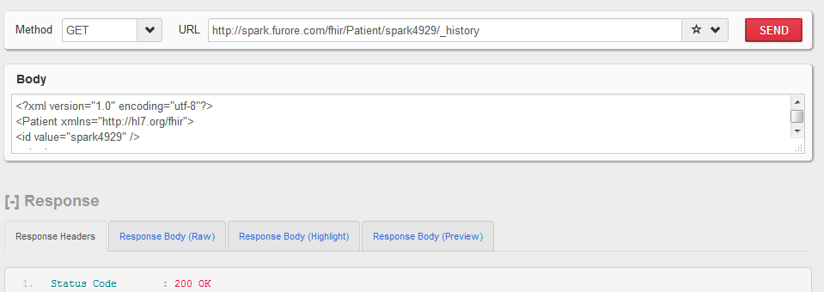

5.delete patient
URL: http://spark.furore.com/fhir/Patient/spark4930
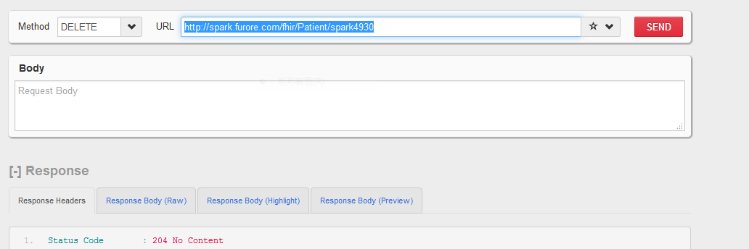

5.search patient
http://spark.furore.com/fhir/Patient?name=刘康

